10 Sutherland Ave.
c. 1913

Lot 188 of the Allan Tract was sold to Mrs. T.M. Keenan on March 12, 1913. A few months later, on June 19, 1913, the property was sold to Mr. Edward J. Murphy. Whether the house had been built already or not is unknown, but by 1914, the house was occupied by office supply salesman Mr. Murphy and his wife, Caroline Murphy. Although the couple owned the house, it appears that they stayed there only until their own home at 500 Huger St. was completed the next year. The Murphys, however, continued to own 10 Sutherland for at least a few more years, during which time, the house was apparently rented out.

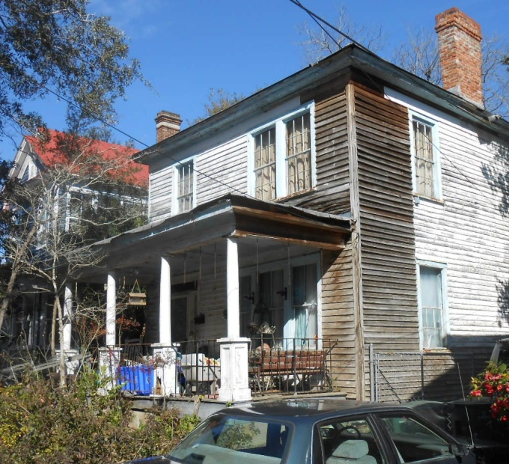
On August 11, 1919, the house was sold to Mattie B. Burn. She and her husband, Louis A. Burn, a conductor for the Atlantic Coast Line, lived in the house for only a short time before selling it. The next owner, Carrie E. Wannamaker, bought the house in April 1922 and returned it to rental property.

On March 23, 1937, the house was sold for $5,000 to Ernest Christopher Hesse, Jr. who, along with his wife, domestic Virginia Hesse, began another period of owner occupation of the house. Mr. Hesse was the secretary-treasurer of Park Pharmacy and professor at the Medical University. Following his wife’s death in 1938, Mr. Hesse continued to occupy the house with both his children and his parents.

The Hesse family remained in the house for almost ten years before selling the home to its next owner, Margaret C. Stafford on July 13, 1950 for $10,000. The Staffords, Naval Base employee Walter A. and Margaret Stafford, occupied the house for longer than any other family to that point.

On January 1, 1965, Clare S. Doscher bought the house for $12,000. The house, at least by 1968, was home to Paul M. Hollingsworth and Julia E. Hollingsworth and their children. Mr. Hollingsworth owned Paul’s Grocery and also two Charleston restaurants. Paul Hollingsworth acquired the house on April 25, 1972, and the family continued to reside there. In 1989, the house did have a different occupant listed, state employee Ronald and Hilda Davis.

After Mr. Hollingsworth’s death in 1990, Julia Hollingsworth was again listed at the house. The house was inherited by Julia and their daughter, Helen H. Lajoie. After Julia Hollingsworth herself died on December 5, 1996, her estate conveyed, on September 29, 1997, her remaining one-half interest in the house to Helen H. Lajoie.

In 2016, a massive restoration of the house was begun by its new owners. Because of the extraordinarily unsanitary conditions in the house, the plaster and floors had to be removed. The work was performed by award-winning contractor Marc Engelke.

(R26, page 243)
(F26, page 313)
Renters included traveling salesman Joseph E.V. Jervey and Jessie Jervey (1915); lawyer Arthur L. and Sue F. King (1916-1917); Navy Yard policeman Osimus L. and Janie Still (1918); and Navy Yard clerk Fred W. Haltiwanger and Frances Haltiwanger (1918-1919).
(O29, page 17)
(T30, page 251)
Renters included Chamber of Commerce secretary, secretary of the Port Utilities Commission, and commission of the Charleston Traffic Bureau Thomas J. and Georgia Lee Burke (1923-1924); Atlantic Coast Line trainmaster Elmore Clifford and Opal W. Clark (1925-1928); Atlantic Coast Life Insurance Co. president Yancy Wilcox Scarborough and Lillie T. Scarborough. He was the president of the Atlantic Coast Life Insurance Co. (1929-1932); engineer George C. and Helen G. Boniface (1933); ship mate Irving Borgen and Christine Borgen (1933); and moving and hauling businessman Harry A. and Helen Dengate (1936).
(b. June 26, 1893; d. Mar. 15, 1961) Charleston News & Courier, Mar. 16, 1961, at 11A
(b. Sept. 1, 1895; d. Sept. 22, 1938)
(G52, page 509)
(d. Feb. 4, 1963) Charleston News & Courier, Feb. 5, 193, at 7A
(A82, page 202)
(b. July 9, 1920; d. Aug. 16, 1990)
Charleston News & Courier, Aug. 18, 1990, at 11C
(C99, page 175)
(O290, page 161)

